CSC675-775, Section 3

Flight Monitor

Team7 Milestone 2

(Lead) - pcalenzani@gmail.com

(Back-end) - jkwan3@mail.sfsf.edu

(Back-end) - cpurav@mail.sfsu.edu

(Front-end) - zwei@mail.sfsu.edu

(Front-end) - nsingh4@mail.sfsu.edu

(Front-end) - kobez2417@gmail.com

Piero Calenzani Jimmy Kwan Chinmay Purav Jason Wei Navneet Singh Pratik Singh

# 1. ERD

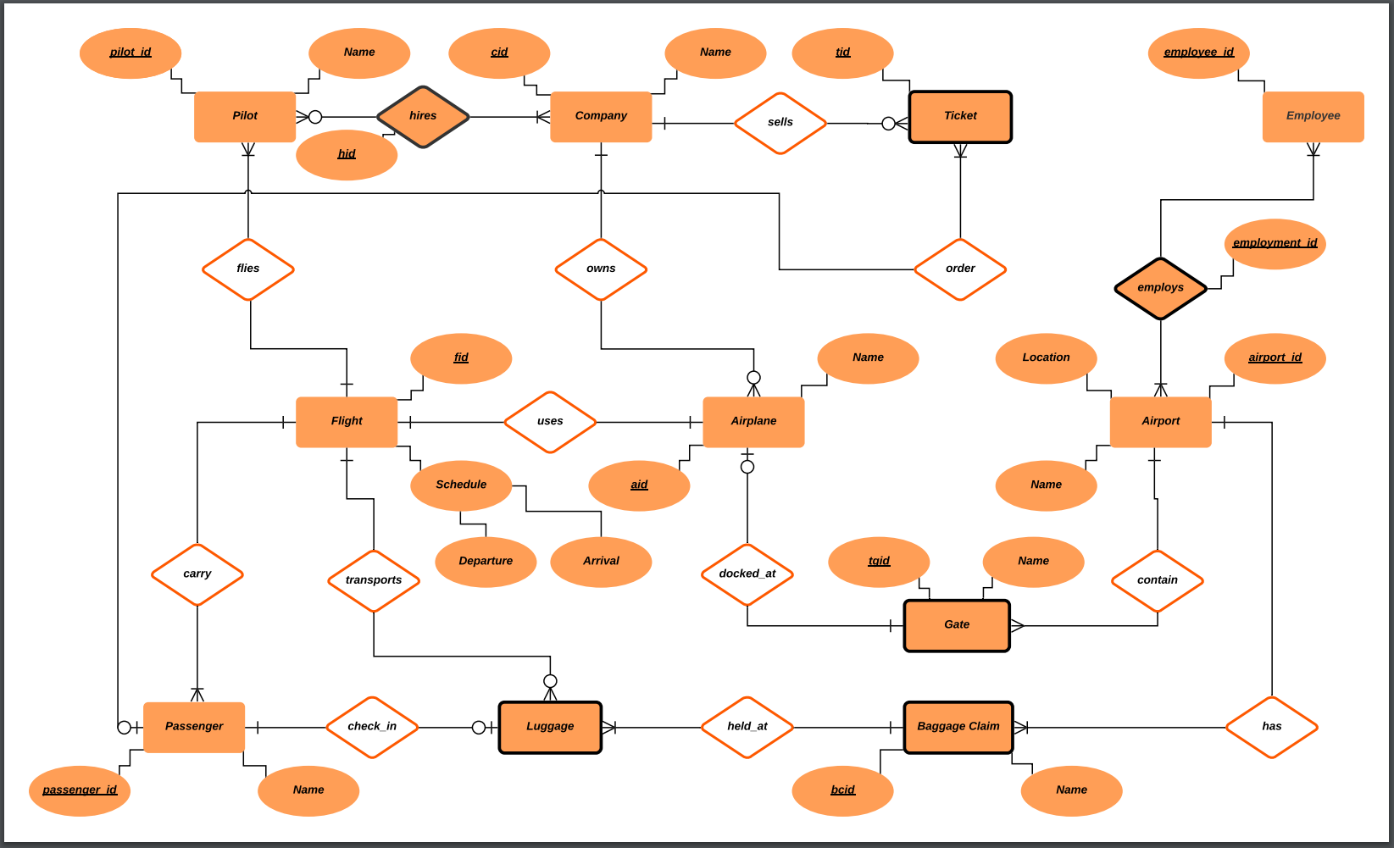

# 2. Database Model

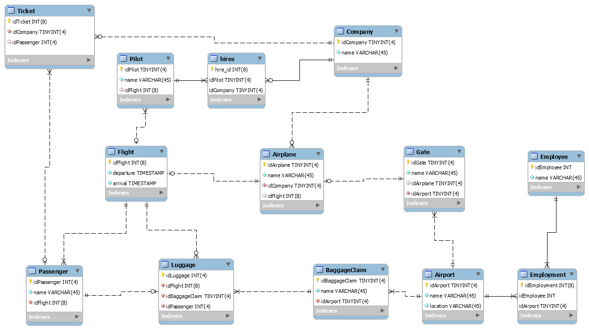

# 5. Database Model Test

|  |  |  |  |  |  |  |
| --- | --- | --- | --- | --- | --- | --- |
| Test # | Test Type | Entity1 | Relationship | Type Rel | Entity2 | Pass/Fail |
| 1 | Delete | Flight |  |  |  | Pass |
| 2 | Delete | Passenger |  |  |  | Pass |
| 3 | Delete | Airport |  |  |  | Pass |
| 4 | Delete | BaggageClaim |  |  |  | Pass |
| 5 | Delete | Pilot |  |  |  | Pass |
| 6 | Delete | Company |  |  |  | Pass |
| 7 | Delete | Airplane |  |  |  | Pass |
| 8 | Delete | Employee |  |  |  | Pass |
| 9 | Select | Airport | Contain | 1 to M | Gate | Pass |
| 10 | Select | Passenger | Carry | M to 1 | Flight | Pass |
| 11 | Select | Employment |  | M to M |  | Pass |
| 12 | Update | Airport |  | 1 to M |  | Pass |
| 13 | Update | Passenger |  | M to 1 |  | Pass |
| 14 | Update | Employment |  | M to M |  | Pass |

# 6. Work Done by Members

Work done by each team member. Enumerated on a scale from 1-10.

*Note*: Nearly all the work for this milestone was done as a single group so everyone was given the same score.

* + - 1. Piero (Team Lead) - 8
* Helped create DBM
* Helped test SQL Scripts
  + - 1. Jason - 8
* Helped create DBM
* Helped test SQL Scripts
  + - 1. Jimmy - 8
* Wrote SQL Scripts
* Helped test SQL Scripts
  + - 1. Chinmay - 8
* Helped create DBM
* Helped test SQL Scripts
  + - 1. Navneet - 8
* Helped create DBM
* Helped test SQL Scripts
  + - 1. Pratik - 8
* Helped create DBM
* Helped test SQL Scripts